https://github.com/MSigging/IS301_StructProg.git - The link to my submitted folder via GitHub.

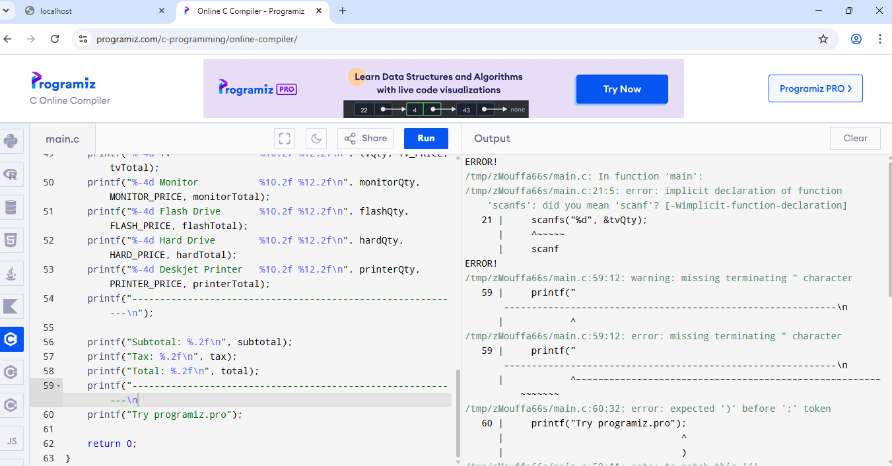
First Error.

After I fixed the code.
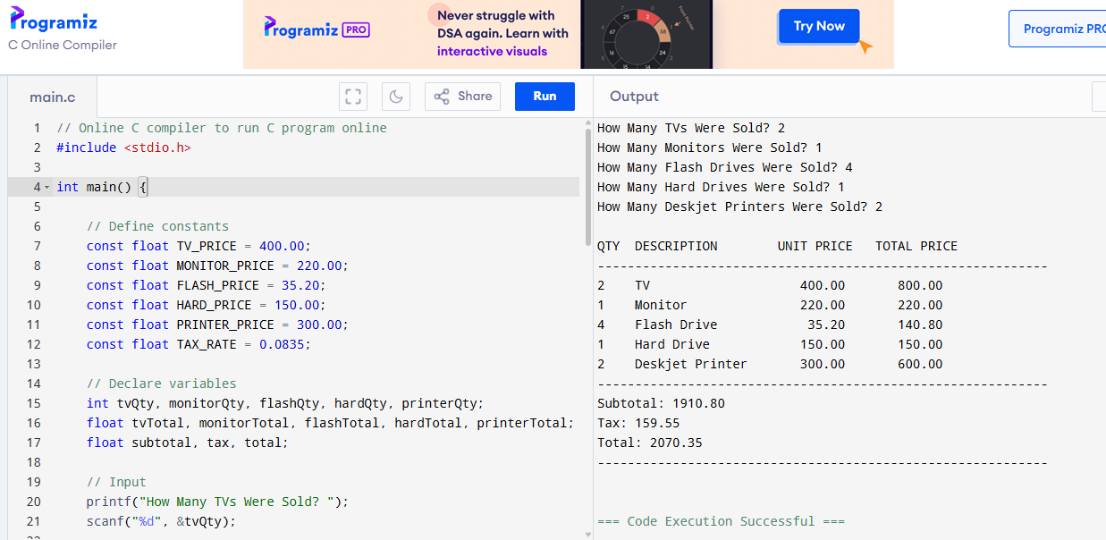
First Set was a success.
Second Set was a success.
